PROJECT TITLE
CAO:

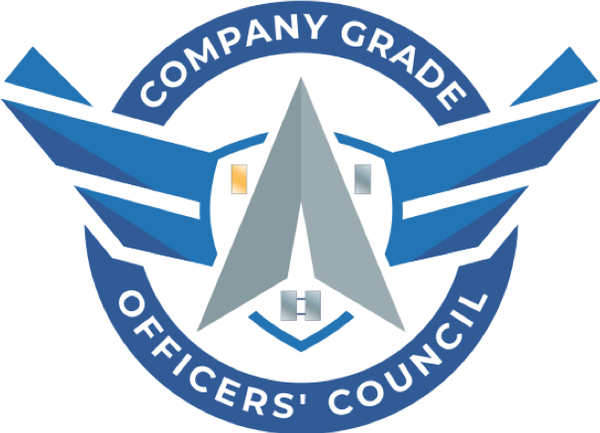

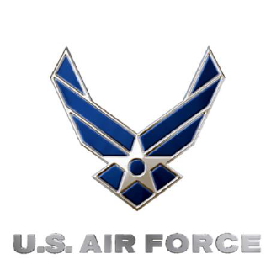




Mission Statement: The Dept. of the Air Force Company Grade Officers' Council connects base councils globally to grow and develop leaders by leveraging Department of the Air Force resources to build a robust community of Lieutenants and Captains.

Vision Statement: To empower councils at Air Force and Space Force units around the world through Advocacy, Recognition and Communication to the regions down to the base-level. The DAFCGOC will coordinate and disseminate training materials and deliver the pulse of the CGO from its constituent councils to senior military leadership.
BASE CGOC

ROADMAP

SECTION 0 – GUIDE PURPOSE
Include General Writeup on Product
Purpose: The intent of this guide is to:
1) X
2) X
Note: This Guide is intentionally left in word to allow base CGOCs to customize it to document

SECTION I – X

XXXX

1. X Content
- X Content
  - X Content
    - Content

SECTION II – X

